**LAPORAN TUGAS**

**DECISION TREE**



**KECERDASAN KOMPUTASIONAL E (C)**

**05111740000069 M.Fatih**

**Dosen:**

**Dini Adni Navastara**

**Departemen Teknik Infomatika**

**Fakultas Teknologi Informasi dan Komunikasi**

**Institut Teknologi Sepuluh Nopember**

**Surabaya**

**2019**

1. Data Training dan Data Testing

Pada decision tree untuk Klasifikasi, splitting data dengan menggunakan k-Fold Cross Validation. Data k nya adalah :

* 3-Fold Cross Validation
* 6-Fold Cross Validation
* 9-Fold Cross Validation

1. Model Decision Tree

* 3-Fold Cross Validation (Gini)

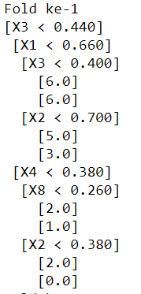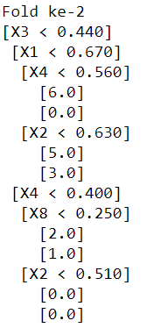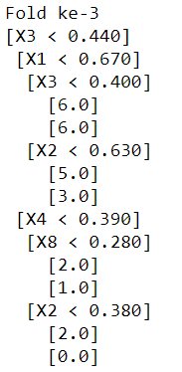

* 3-Fold Cross Validation (Entropy)

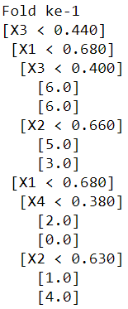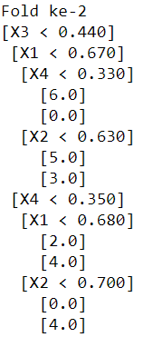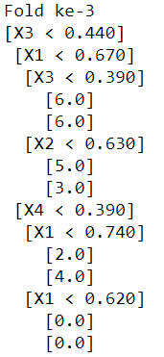

* 6-Fold Cross Validation (Gini)

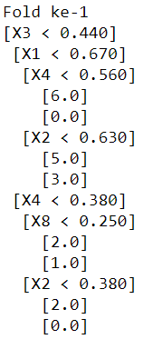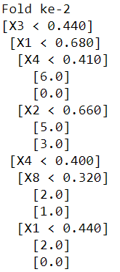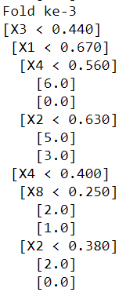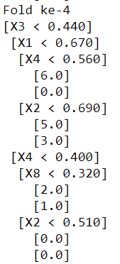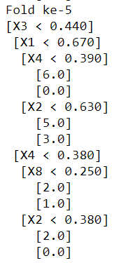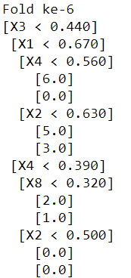

* 6-Fold Cross Validation (Entropy)

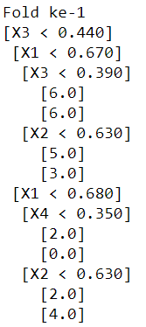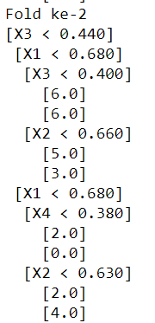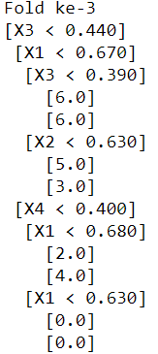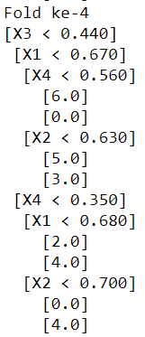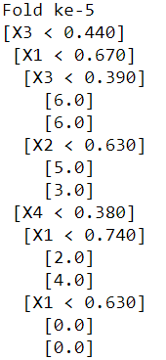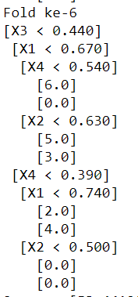

* 9-Fold Cross Validation (Gini)

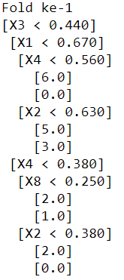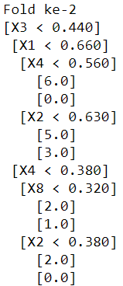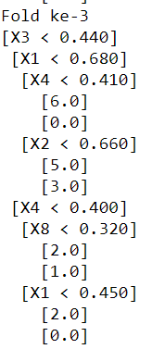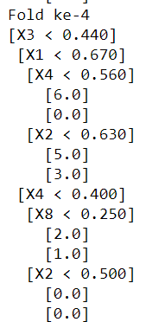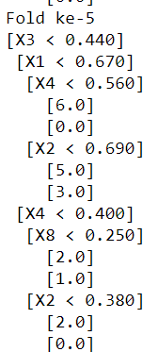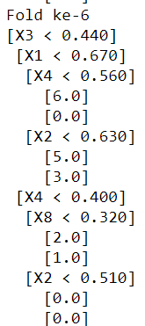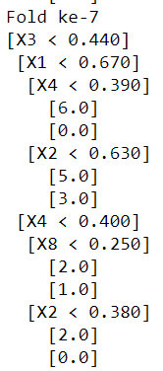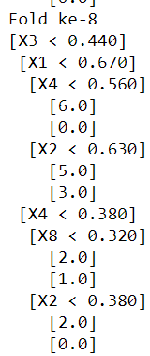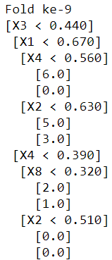

* 9-Fold Cross Validation (Entropy)

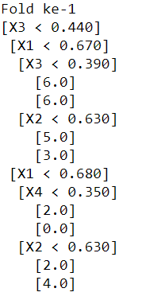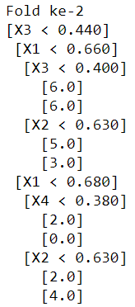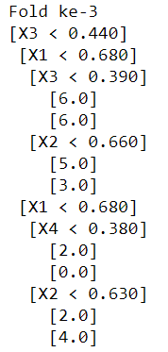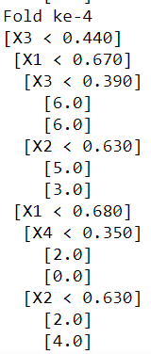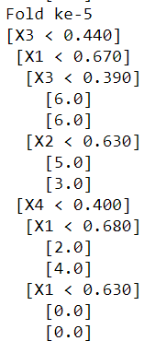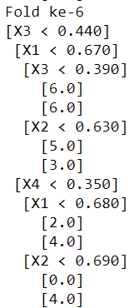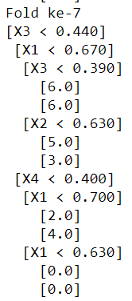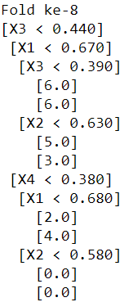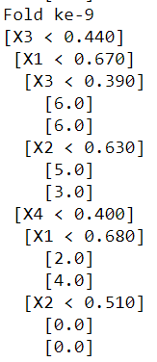

1. Hasil Pengukuran Performance

* 3-Fold Cross Validation (Gini)

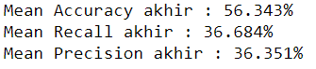

* 3-Fold Cross Validation (Entropy)

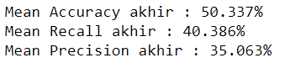

* 6-Fold Cross Validation (Gini)

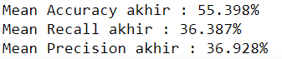

* 6-Fold Cross Validation (Entropy)

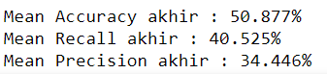

* 9-Fold Cross Validation (Gini)

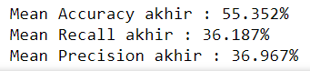

* 9-Fold Cross Validation (Entropy)

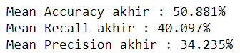

Source code :

<https://github.com/trasv/KK_C/blob/master/Decision_Tree/DT.py>

Referensi

<https://machinelearningmastery.com/implement-decision-tree-algorithm-scratch-python/>